**REPORT**

**ON**

**DRONE BASED INTELLIGENT ET SENSING SYSTEM AND IRRIGATION WATER USE ACCOUNTING SYSTEM**

**PROBLEM STATEMENT ID – 1571**

**THEME – ROBOTICS AND DRONES**

**PS CATEGORY - HARDWARE**

**SUBMITTED BY**

**TEAM NAME – AGRO - AERO**  
  
  
  
  
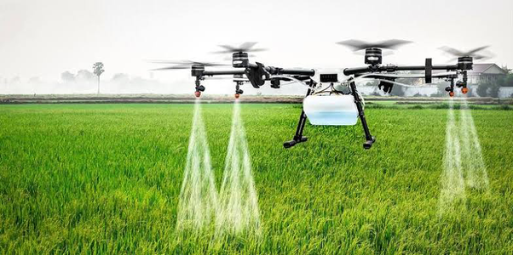  
  
  
  
  
  
**INTRODUCTION**

The project “Drone- based Intelligent ET Sensing System and Irrigation Water Use Accounting System” was prepared for the Smart India Hackathon (SIH) under the Drones theme. The problem statement, ID 1571, falls under the Hardware category. The project was developed by the team Agro-Aero.

**PROJECT OVERVIEW**

The project focuses on a drone-based irrigation system designed to enhance agricultural practices. The system uses drones equipped with various technologies to perform efficient irrigation, pesticide spraying, and environmental monitoring. The primary goals include optimizing water usage, reducing chemical exposure to farmers, and improving crop yields.

**TECHNICAL APPROACH**

1. **Drone Design and 3D Printing:**

* The project involves designing several components using 3D printing, including the drone itself, a water storage tank, and nozzles for spraying water. By utilizing 3D printing, we were able to manufacture custom parts at a lower cost compared to traditional methods, making the drone more affordable and accessible for widespread use in agriculture.
* The drone is equipped with a water transpiration system to manage the irrigation process.

|  |  |
| --- | --- |
|  |  |

**Fig no 1: Side View and Isometric view of SolidWorks Model**

1. **Hardware Used:**

**2.1. Arduino UNO R3**

This microcontroller is based on the ATmega328P. There are total of 20 pins (0-19) out of which 6 are analog inputs,14 are digital input output pins(6 pins provide PWM voltage) which can also be used as general purpose pins, a ceramic resonator of frequency 16 MHz, an USB connection, a power jack and a reset button. It has an operating voltage of 5V. It contains everything needed to support a microcontroller.

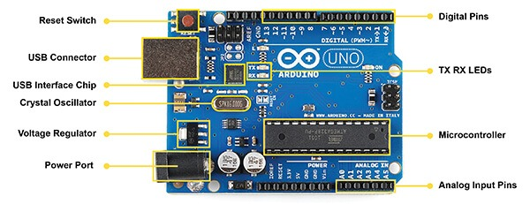

**Fig no. 2. Arduino UNO R3**

**2.2 LCD**

Liquid Crystal Display, which we are using in our project is16*2 LCD. This display consists of 16 columns and 2 rows. This is programmed using the library<LiquidCrystal.h>

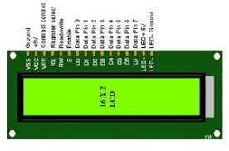

**Fig no.3: LCD**

**2.3 Soil Moisture Sensor**

A soil moisture sensor measures the water content in soil by detecting changes in electrical properties. In the drone-based irrigation system, it provides real-time moisture data, helping to optimize irrigation by ensuring water is applied only when needed. This leads to efficient water use and healthier crops.

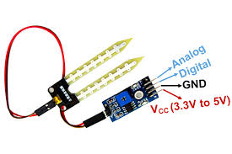

**Fig no. 4: Soil Moisture Sensor**

**Methodology and Circuit Design:**

* The system integrates a GPS-based positioning system connected to an Arduino UNO R3 board. The Arduino sends signals to the Electronic Speed Controller (ESC), which controls the drone’s movement and location with position.
* A soil moisture sensor is also used to measure the moisture content in the soil, displaying the data on an LCD screen. This sensor helps in classifying soil as dry or humid, and the system adjusts the pump speed accordingly to ensure optimal irrigation.

|  |  |
| --- | --- |
|  |  |

**Fig no. 5: Circuit Model and Real Circuit Model of Soil Moisture Sensor**

1. **System Components:**

* The drone system is designed to be used as a water sprinkler for various applications, including sports ground irrigation, plant nurseries, and difficult terrains. It is also capable of spraying pesticides, insecticides, and herbicides.

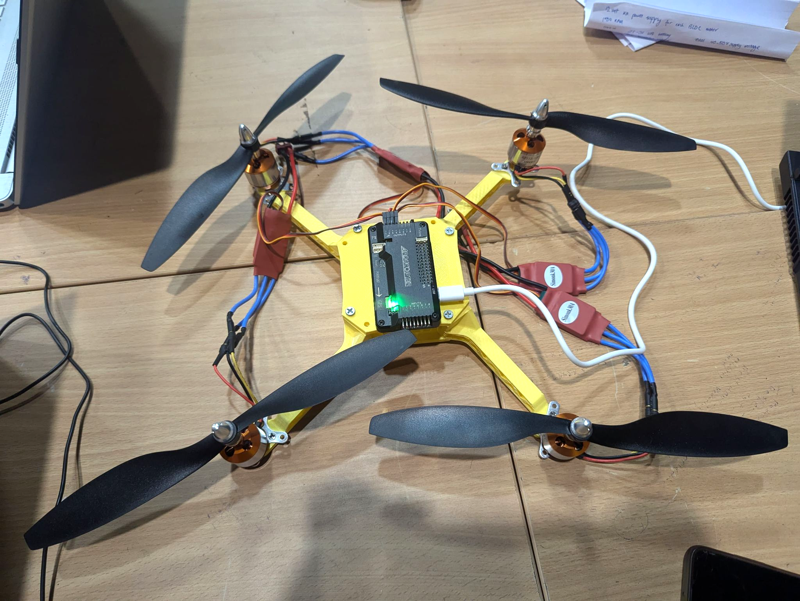

**Fig no.6: Working Model of Design**

**IMPACT AND BENEFITS**

1. **Reduced Operational Expenses**:

* Drones equipped with thermal or multispectral cameras can detect areas requiring more water, optimizing irrigation and reducing water waste.

1. **Data-Driven Decision Making**:

* Drones provide insights into crop health, soil moisture, and weather patterns, enabling data-driven decisions in farm operations.

1. **Targeted Crop Care**:

* Targeted irrigation can reduce chemical usage by applying treatments only where needed, rather than blanket applications.

1. **Enhanced Accessibility**:

* Drone irrigation can improve accessibility in difficult terrains, making it easier to manage remote or hard-to-reach areas.

**FUTURE SCOPE**

Looking ahead, the integration of advanced technologies like image processing and machine learning (ML) offers significant potential to enhance the drone-based irrigation system. By incorporating image processing capabilities, the system can be equipped with cameras to scan fields and analyze soil conditions in real-time. This data can be used to predict soil health for the upcoming months or even a year, allowing farmers to plan irrigation and fertilization schedules more effectively. Additionally, ML algorithms can be employed to process images captured by the drones to detect weeds accurately. This feature would enable the system to identify and classify different types of weeds, helping farmers to address these issues promptly and reduce crop damage. The early detection and precise management of weeds would not only improve crop yields but also minimize the need for chemical treatments, contributing to more sustainable farming practices.

**CONCLUSION**

The drone-based intelligent ET sensing system and irrigation water use accounting system present a significant advancement in precision agriculture. By integrating technologies like 3D printing, Arduino UNO R3, and soil moisture sensors, the project offers an innovative solution to optimize water usage, enhance crop management, and promote sustainable farming practices. The proposed future enhancements, including image processing and machine learning, promise to further refine the system's capabilities, enabling predictive soil analysis and early weed detection. This project not only addresses current agricultural challenges but also lays the groundwork for a more efficient, data-driven approach to farming, ultimately benefiting both farmers and the environment.